Synopsis

Predictive Analytics for Urban Water Demand

Problem Id: 06

Student Name: Nakshatra Agarwal
University Roll number:2028775
Section: P

Student Name: Manvi Arora
University Roll number:2028761
Section: P

Student Name: Ruhee Gupta
University Roll number:2028829
Section: P

- Problem Description:
- Efficient urban water management is essential due to increasing population, rapid urbanization, and varying consumption patterns. Predicting daily water usage helps optimize supply, reduce wastage, and prevent shortages. This project focuses on developing a predictive analytics model to estimate daily household water consumption and determine whether a particular city is suitable for living based on water availability.
- A synthetic dataset of 200,000 records is curated containing multiple metropolitan cities such as Delhi, Mumbai, Bangalore, Chennai, Kolkata, Hyderabad, Pune, Jaipur, Ahmedabad, and Lucknow. The dataset includes features such as household size, seasonal index, garden area, household income, previous day usage, city population, average rainfall, and average water table. To simulate real-world conditions, decimal values, missing values, and outliers are intentionally introduced.
- Data preprocessing techniques including handling missing values, rounding decimal values, and outlier detection are applied. Feature scaling using StandardScaler is performed before training a Linear Regression model to predict daily water usage. The predicted consumption is then compared with the city’s water table to classify the location as “Suitable” or “Not Suitable” for sustainable living.
- Residual analysis and performance metrics are used to evaluate model accuracy. This project demonstrates how machine learning can support smart city planning and sustainable water resource management.
- Steps of Implementation:
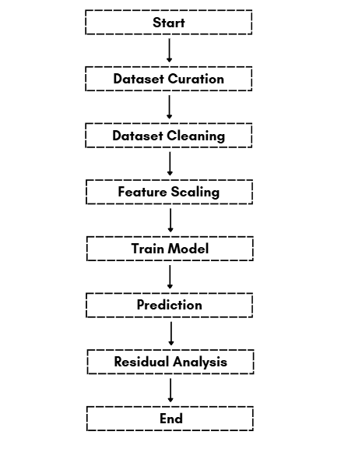

- Expected Modules/ Libraries to be used :
- NumPy
Used for numerical computations and array operations.
- Pandas
Used for dataset handling, cleaning, and manipulation.
- Scikit-learn
Provides tools for StandardScaler and Linear Regression.
- Matplotlib / Seaborn
Used for visualization of data and residual plots.
- Expected Evaluation metrics and Plots to be used:
Metrics:
- Mean Absolute Error (MAE)
- Mean Squared Error (MSE)
- Root Mean Squared Error (RMSE)
- R² Score
Plots:
- Residual Plot
- Actual vs Predicted Plot
- Box Plot (Outlier detection)
- Distribution PlotRequired topics from the subject:

1. Data Preprocessing: Involves cleaning and preparing raw data before feeding it into the model
2. Feature Scaling (StandardScaler): StandardScaler is used to normalize features so that they have zero mean and unit variance.
4. Linear Regression:A statistical method used to model the relationship between dependent and independent variables.
5. Scikit-learn (sklearn) Library: A Python library used for implementing machine learning algorithms.
6. Data Visualization: Using libraries like Matplotlib or Seaborn to plot graphs such as residual plots and prediction comparisons for better understanding.

- Platform Required:
Visual studio/ MS excel
- Books and Link Sources:
- Hands-On Machine Learning – Aurélien Géron
- Python for Data Analysis – Wes McKinney
- Scikit-learn Documentation
- Kaggle (Dataset and ML references)
- Prompt used for dataset:
“let's make a data set of 2Lakh values in which the columns are going to be city, household size, seasonal index, garden area, average rainfall, household income, previous day usage, city population, and the target variable daily water used, and also the average water table at that place for the last five years so that we can also predict If that place is suitable to live or not based on the if-else conditions.”

“now add the suitability column”
“deliberately add decimal values of random range so that I can round it off as a part of data pre processing , add 5% null values, inject outliers

“there should be no null values in the city column household size should be a natural number seasonal index should be in randomly 1to3 decimal places garden area should be in randomly 1 to 3 decimal places house hold income should be in multiples of hundred with no decimal values(eg-55500) prev day usage should be in randomly 1 to 3 decimal places daily water used should be in randomly 1 to 3 decimal places keep daily water used and prev day usage almost similar water table for a particular city should be same in every row”

